

**Year 7 Earth and Space Sciences 2021**

***Mid-Term Test***

**Section 1: Multiple Choice Answers 1 mark each**

*Read all answers and choose the* ***BEST*** *one.*

1. The Earth spins on an angled tilt called a(n):

**A** Revolution

**B** Tilt

**C** Slant

**D** Axis

2. The rotation of the Earth is what causes:

**A** Day and Night

**B** The seasons

**C** an eclipse

**D** a full moon

3. One full revolution of the Earth takes:

**A** One day

**B**  One year

**C** 29 days

**D** 14 Days

4. Which of the following correctly describes the movement of the Sun, Earth and Moon:

**A** The Moon and Earth rotate around the Sun.

**B**  The Sun revolves around the Earth and Moon.

**C**  Sun revolves around the Moon, Moon revolves around the Earth.

**D** Moon revolves around the Earth and the Earth revolves around the Sun.

5. The movement of the Earth around the Sun is called:

**A**  Oval

**B**  Elliptical

**C**  Rotation

**D** Revolution

6. A leap year occurs every:

**A** 10 years

**B** 3 years

**C** 4 years

**D** 40 years

7. How many days in a leap year:

**A** 29 Days

**B** 366 Days

**C** 367 Days

**D** 364 Days

1. 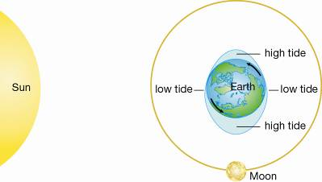8. The phase of the moon in the above Question 8 picture is:

**A** new moon.

**B** first quarter.

**C** full moon.

**D** last quarter.

9. An equinox is best described as the point at which:

**A** The Earth is furthest from the Sun.

**B** The Earth experiences its’ longest day.

**C** The Earth has an equal day and night.

**D** The Earth is closest to the Sun.

10. How many high tides are there in 24 hours?

A 1

**B** 2

**C** 3

**D** 4

1. 11. A lunar eclipse is when:

**A** the Moon travels around Earth in an orbit shaped like an oval.

**B** Earth blocks sunlight from reaching the Moon.

**C** the Moon blocks sunlight from reaching the Sun.

**D** you only see part of the Moon because of its angle to the Sun.

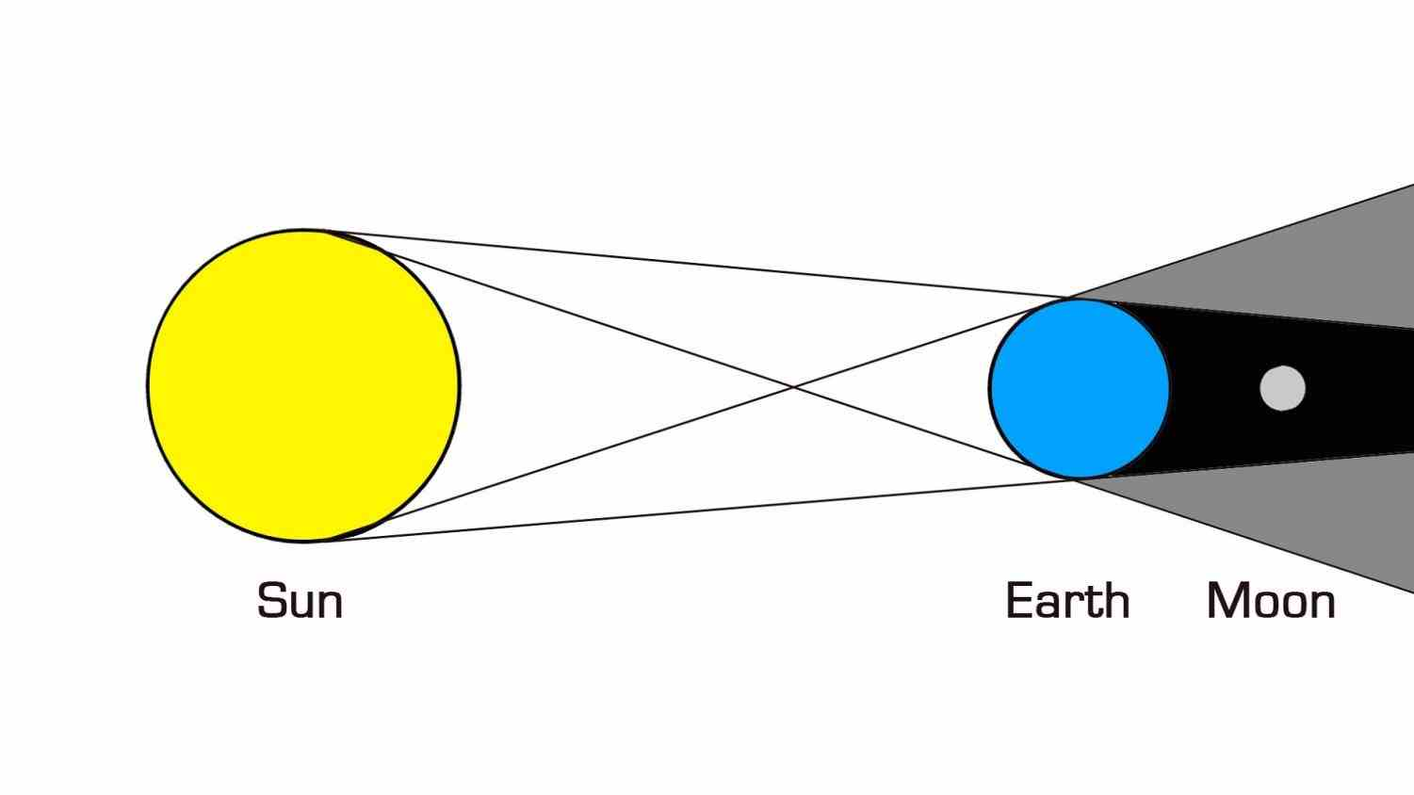12. What is occurring the picture below:

**A** A Partial Solar Eclipse

**B** A Partial Lunar Eclipse

**C** A Total Lunar Eclipse

**D** A Total Solar Eclipse

**Section 2: Short Answer Total XX marks**

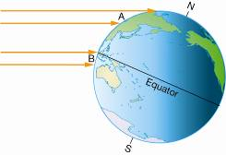

**Sunlight**

**Sunlight**

1. 1. a) **State** the season in each hemisphere shown in this diagram:

**Summer**

**Winter**

1. Northern: ________________ Southern: ________________ (1 mark)
2. b) **Explain** why the seasons are different in each hemisphere. (3 marks)

Because of **axial tilt/**the **axis is tilted** (1 mark)

one hemisphere **gets more sunlight - summer** (1 mark) **tilted towards = ½**

and the other hemisphere **gets less sunlight – winter (**1 mark) **tilted away = ½**

Explain = full sentences **Facing the sun** is not correct

1. ________________________________________________________________________________________________________________________________________________________________________________________________________________________________________________________

6. a) **Construct a labelled diagram** to show what a **Solar** eclipse is. (4 marks)

*(remember to name the parts of the shadow).*

1. O = Order T = Terminology
2. 1 mark – correct position of Sun, Moon Earth
3. 1 mark – earth and sun are labelled
4. 1 mark – moon is labelled (1/2) and it’s shadow does **not** cover all of earth (1/2)

Shadows don’t spread out

1 mark – Umbra and Penumbra are labelled.

1. b) **Explain** why we can have a Full Moon sometimes and a **Lunar** eclipse at other times.

(3 marks)

Because the moon **orbit is tilted** – 1 mark Moon is not tilted!

The moon will sometimes go into **earth’s shadow = Lunar Eclipse** – 1 mark

Most of the time, the moon will **not go** **into earth’s shadow = full moon** – 1 mark

|  |
| --- |
|  |
|  |
|  |

***- End of Test –***